Virtual Box setting where I installed kafka:

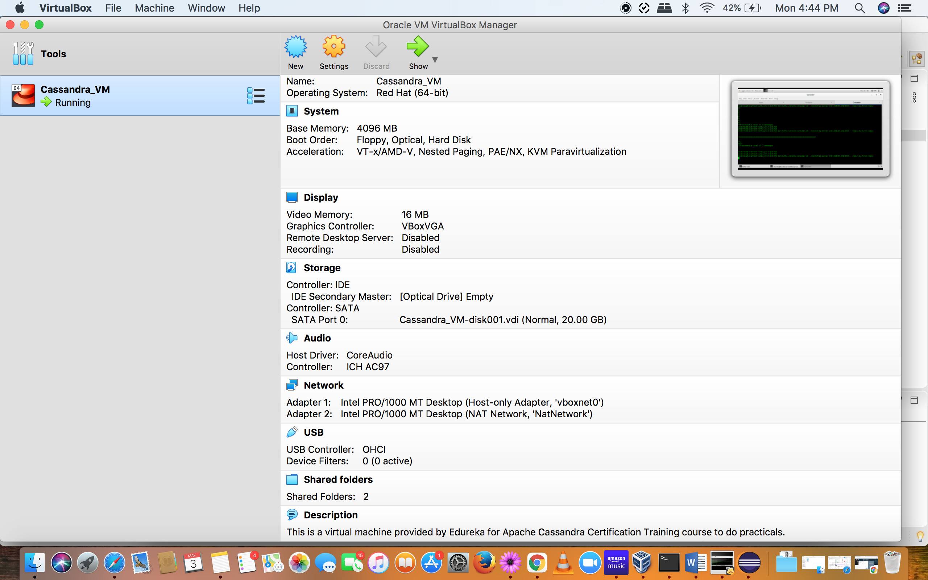

Virtual machine IP address:

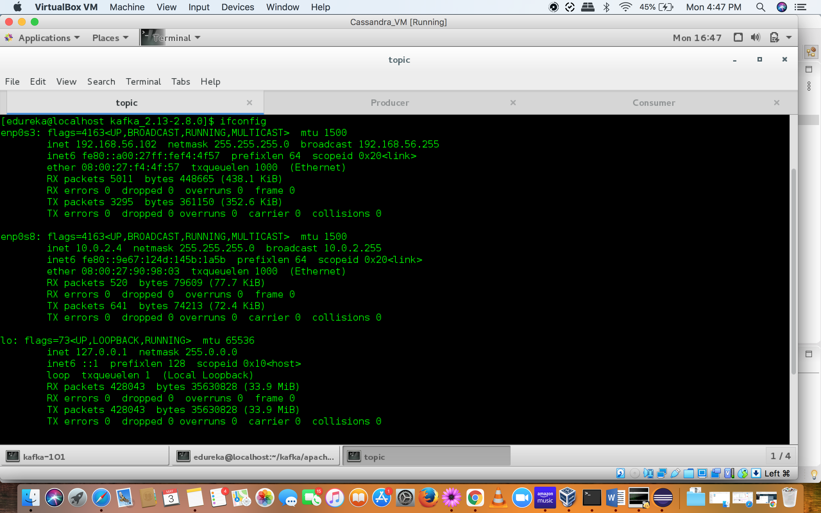

My machine IP address:

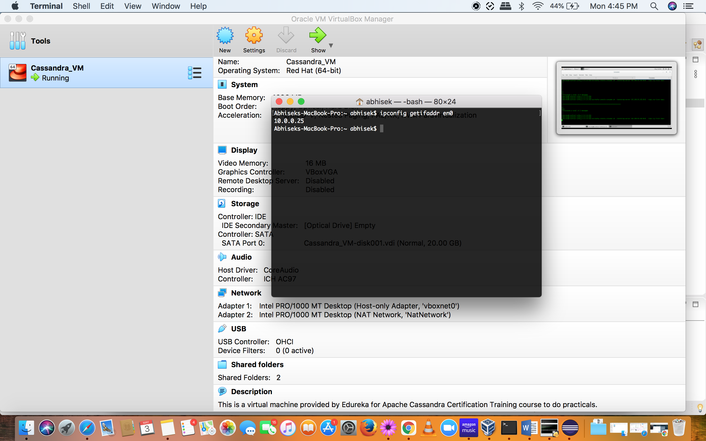

Able to send messages from console producer to console consumer as follows:

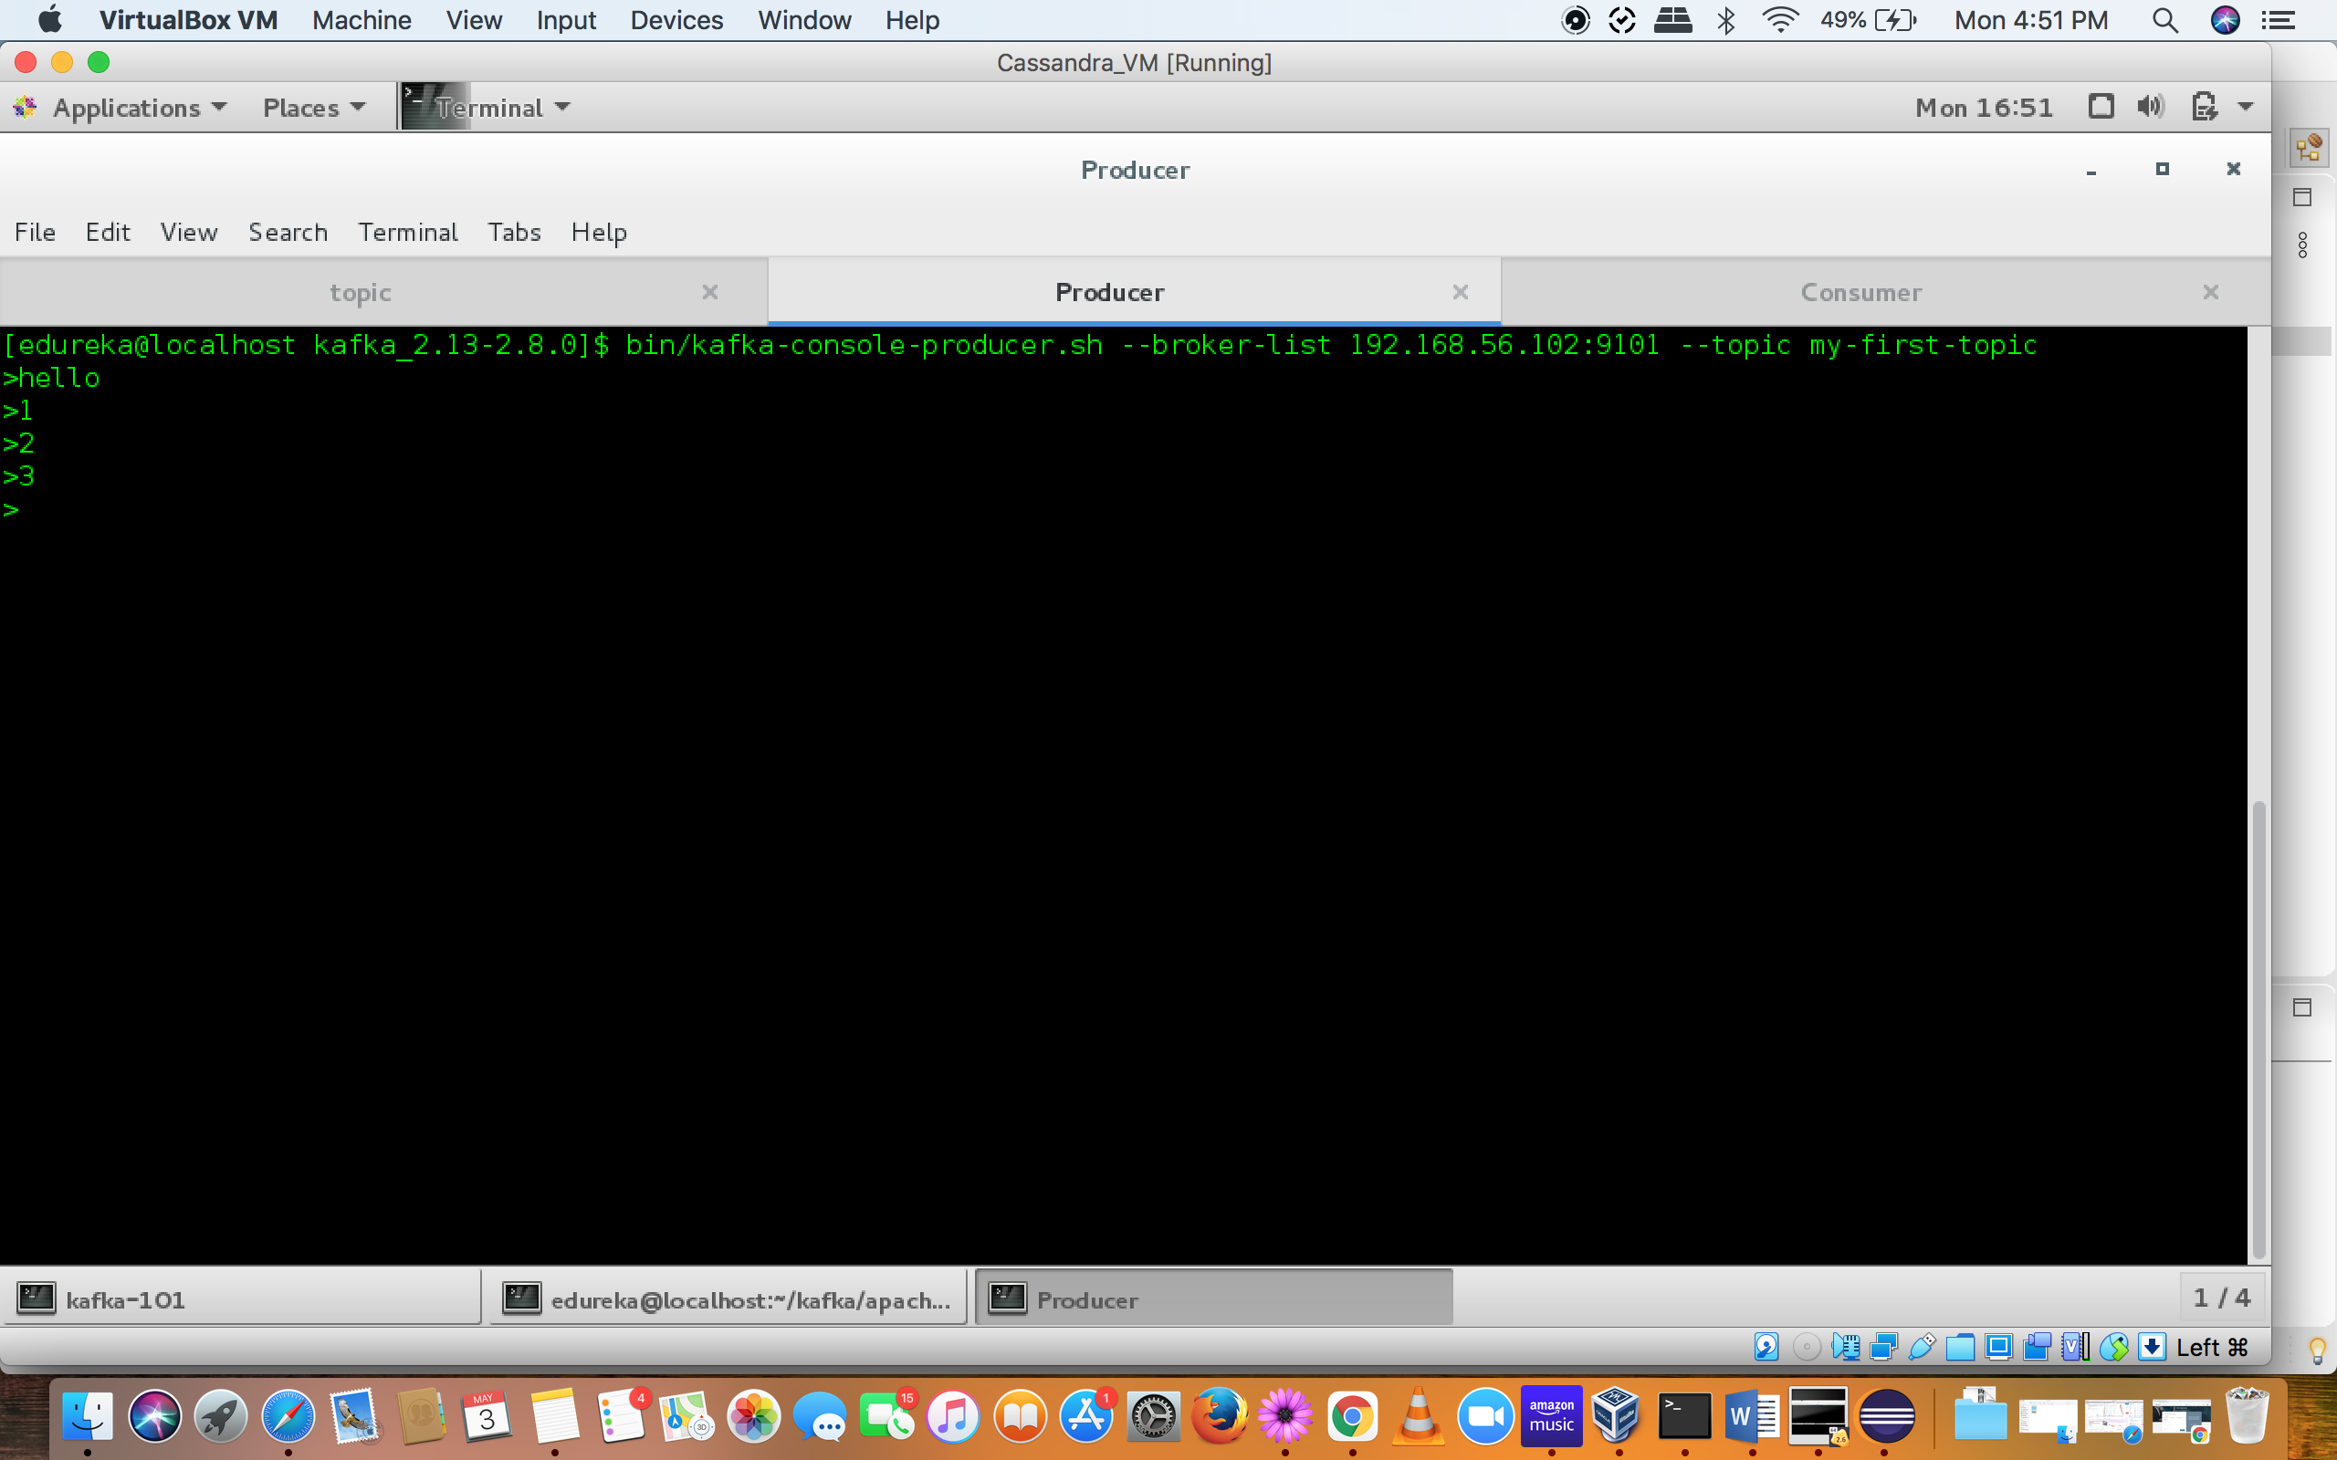

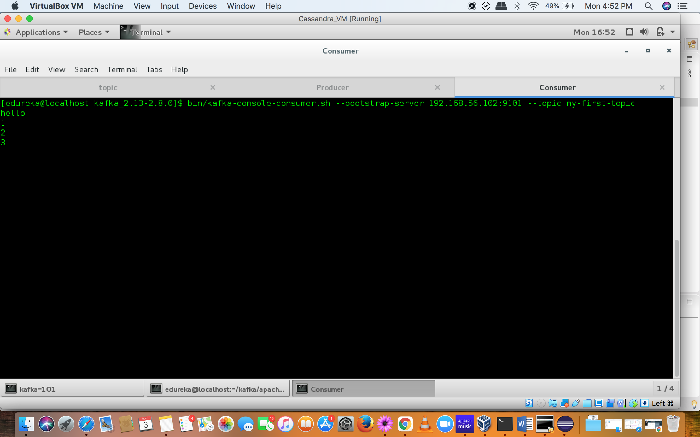

But unable to send messages when running from producer through Eclipse:

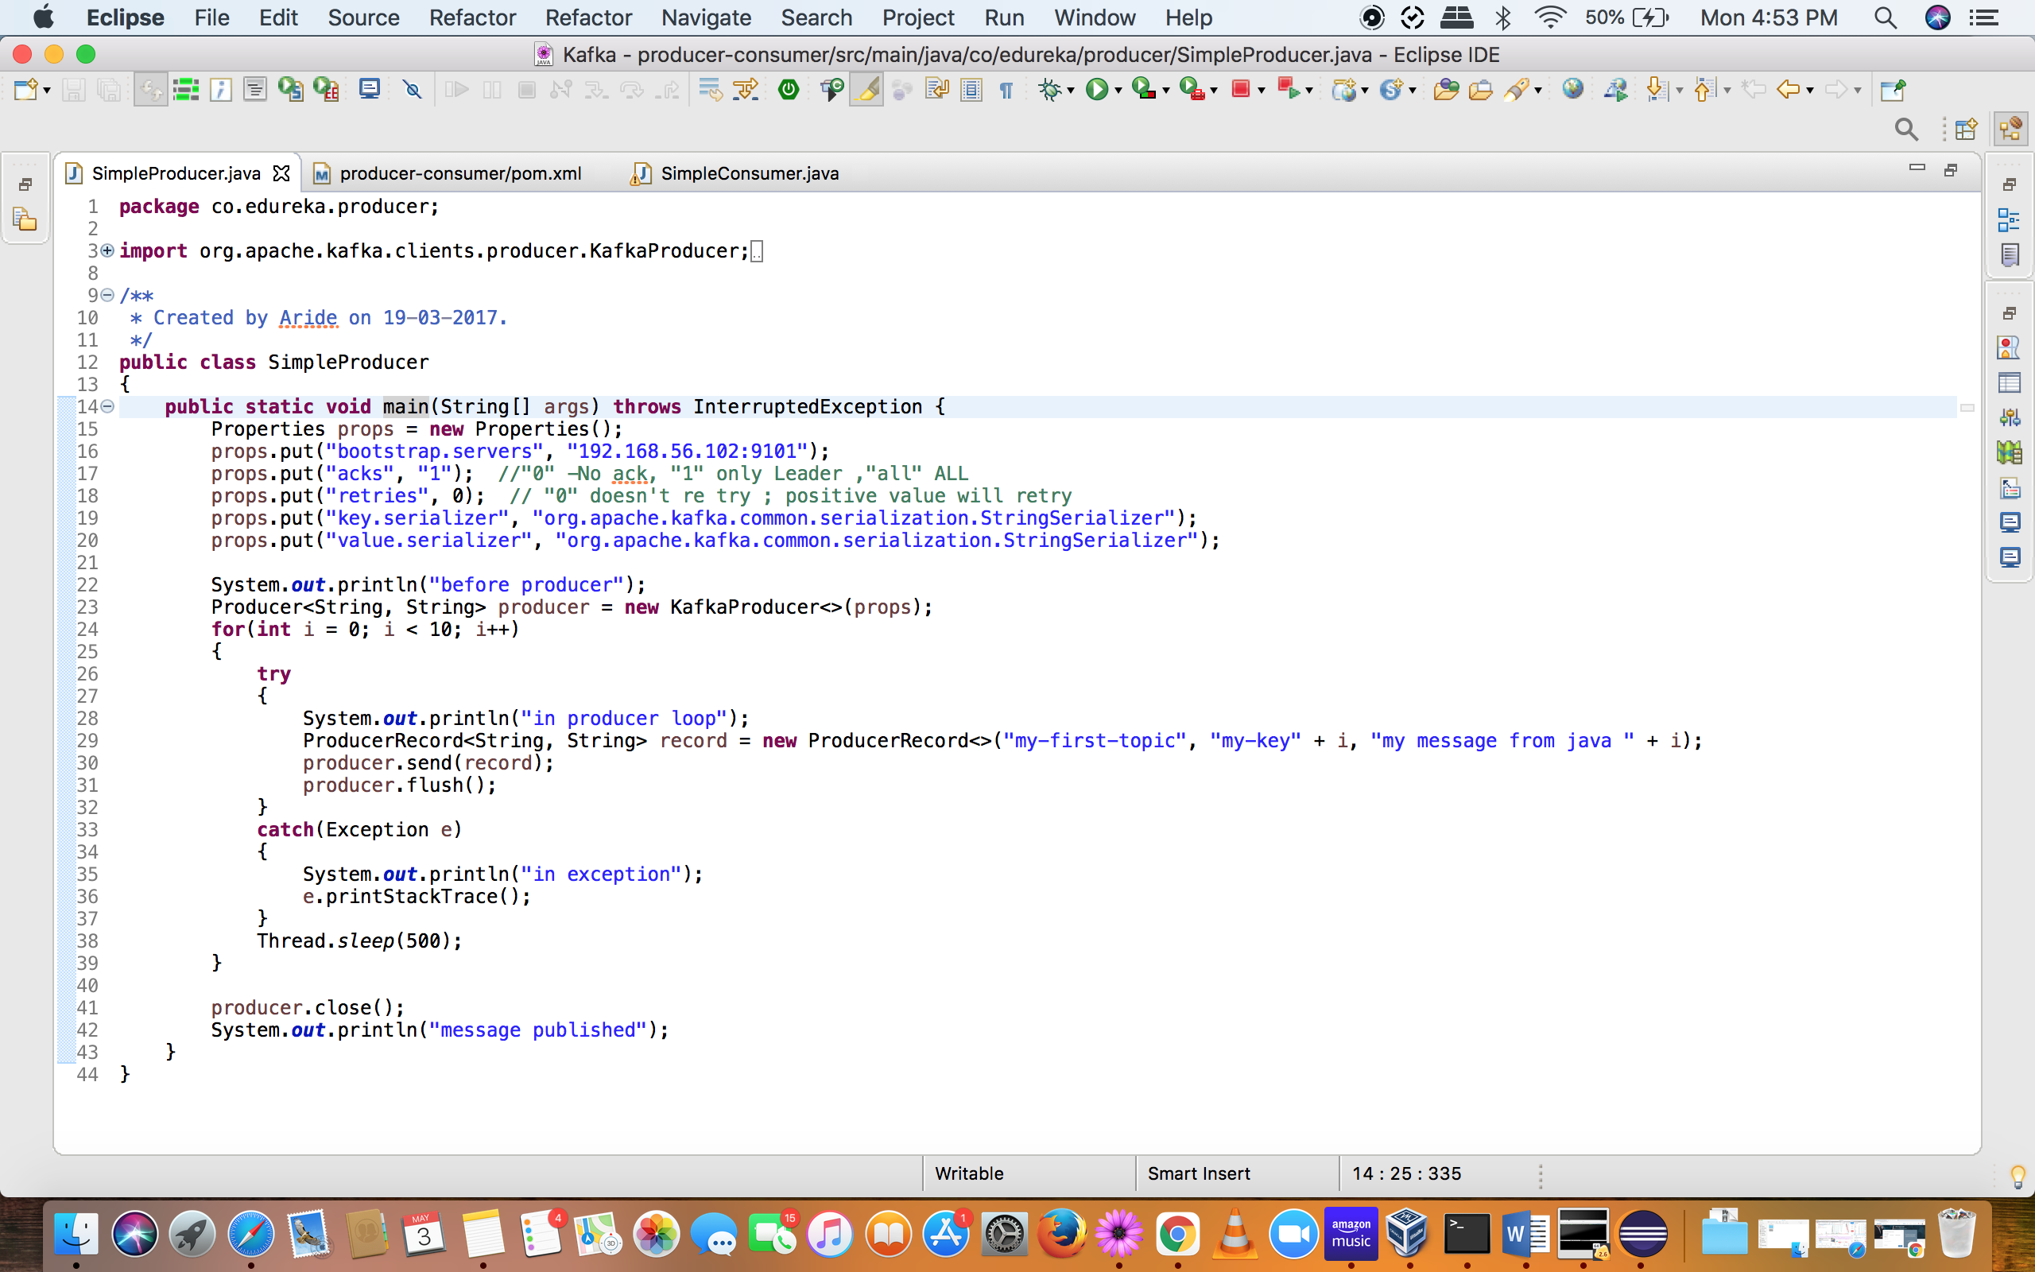

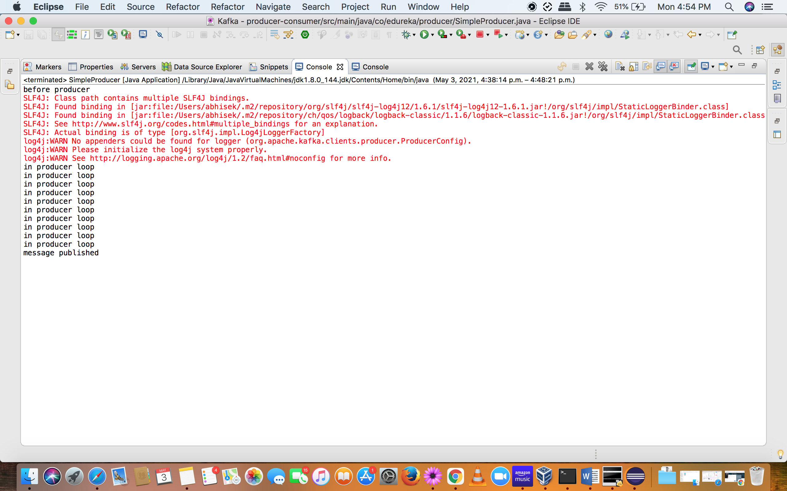

Neither I can receive messages in kafka console producer nor do I get it in kafka consumer when run through separate instance in eclipse.

This same exercise was done by instructor.

Please assist if I have done some incorrect configuration.

NOTE: this producer consumer code is already provided by the instructor in Session#2 under producer_consumer programs folder. Only this I changed was the broker ip at Line#16. Screenshot given below for reference



Kafka server properties file for reference(server-101.properties):

